Group 4

Payton Boekhout

Nic Chiolerio

Songxi Chen

Assignment 4 - Design Focus

Table of Contents

Page 1 - Table of Contents

Page 2-3 - Use Case Diagram

Page 4-6 - Activity Diagrams

Page 7-8 - Class Diagram

Page 9 - ERD Diagram of System

Page 10 - Sequence Diagram

Page 11 - State Machine Diagram

Use-Case Diagram

This is a Use Case Diagram that shows the activity of students submitting assignments and them being graded

Construction - Payton

Peer Review - Songxi, Nic

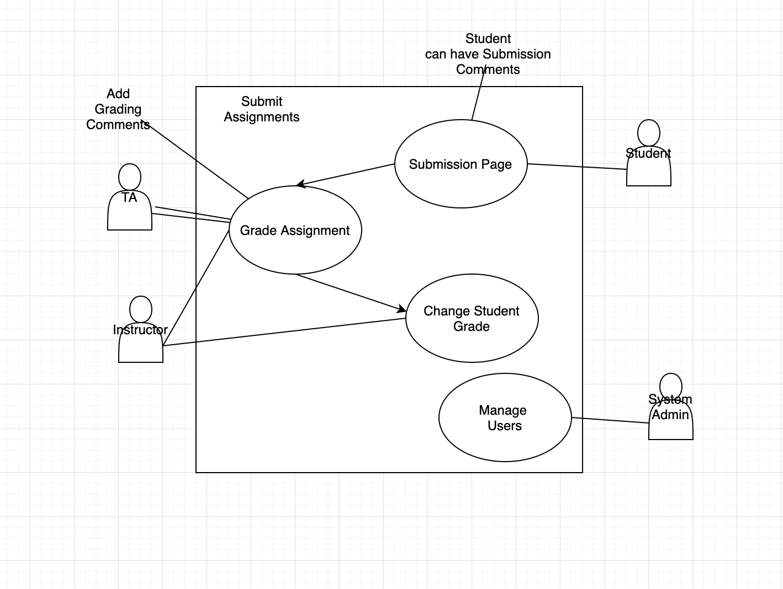

Use-Case Diagram Description

Description of the Use-Case diagram above

Construction - Payton

Peer Review - Songxi, Nic

Primary Actor: Student

Scope: University

Interests: Students- want to submit assignments, TA & Instructor - want to grade assignments

Precondition: Student has website open

Minimal Guarantee: Good logging details so if it goes wrong the system knows to ask the student what went wrong

Success Guarantee: Database collects the submission and the TA and instructor are able to view and grade it

Main Success Scenario:

1. Student submits assignment
2. Submission goes to database
3. TA/Instructor pulls submission from database
4. They grade the submission
5. They change the grade in for user
6. User website gets updated with new grade

Activity Diagrams

Activity 1. Assignment submission and grade receival

Constructed by Nic,

Peer review by Payton and Songxi

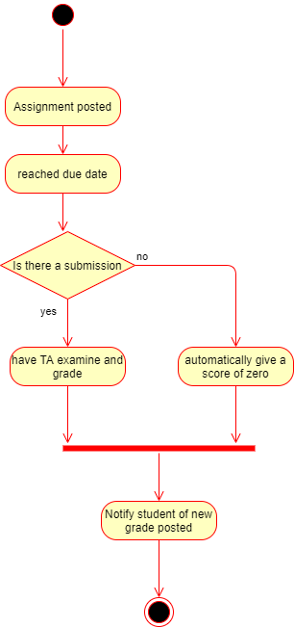

Activity 2 - Student Login/Logout

Constructed by Payton

Peer reviewed by Nic and Songxi

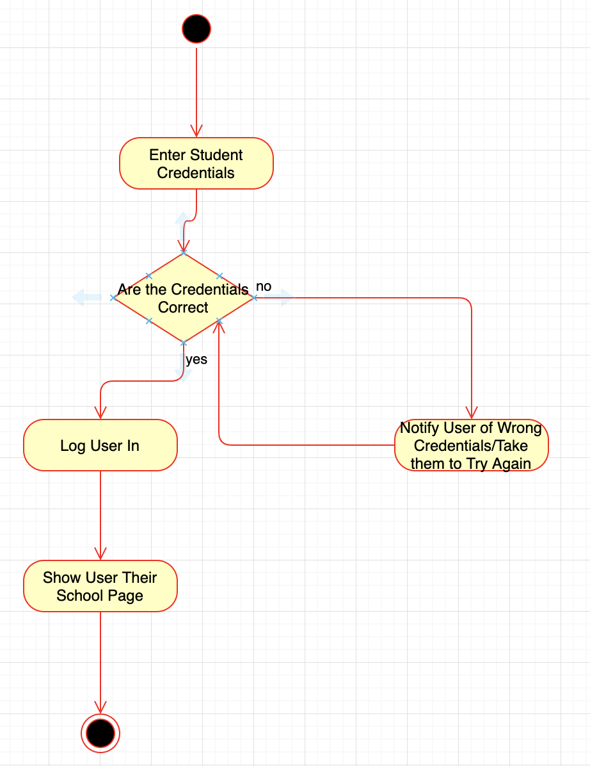

Activity 3 - TA search students in a course

TAs can search only the students who are in the course sections that they are assigned to manage.

Constructed by Songxi

Peer reviewed by Nic and Payton

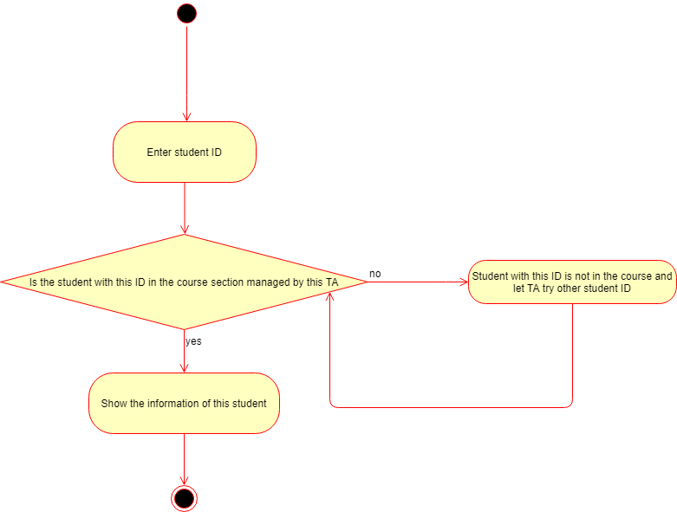

Class Diagram

Activity 1 - Populate a course

Constructed by Nic,

Peer review by Payton and Songxi

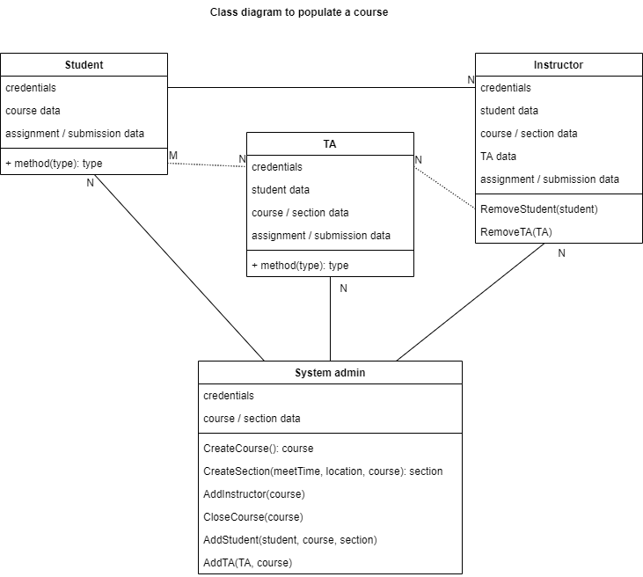

Activity 2 - Student reads assignment instructions

Students can only access assignments of the courses that they are enrolled in.

Constructed by Songxi

Peer reviewed by Payton and Nic

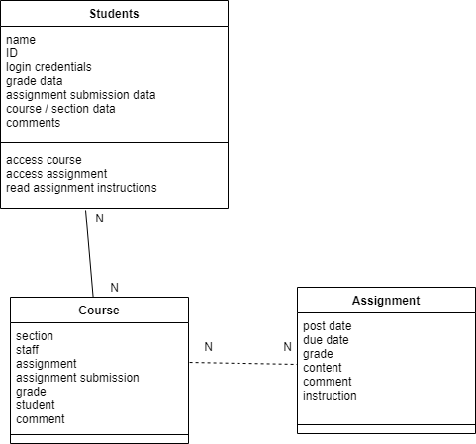

System ER diagram

Made by Nic, peer reviewed by Payton and Songxi

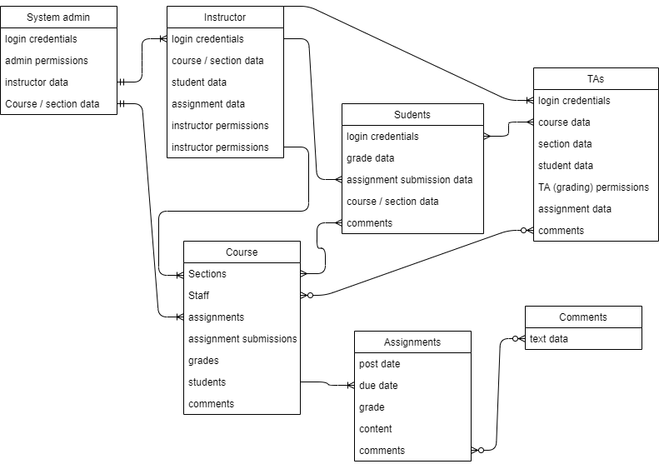

Sequence Diagram

Sequence Diagram of A login attempt for student

Construction - Payton

Peer Review - Nic and Songxi

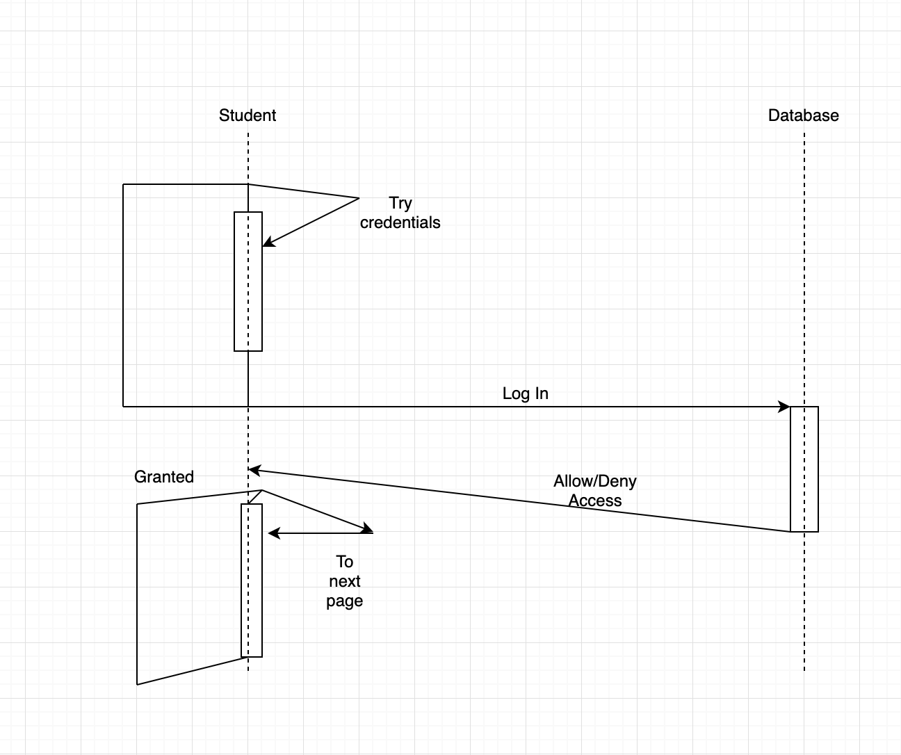

State Machine Diagram

State Machine Diagram of assignment

Construction - Songxi

Peer Review - Nic and Payton

